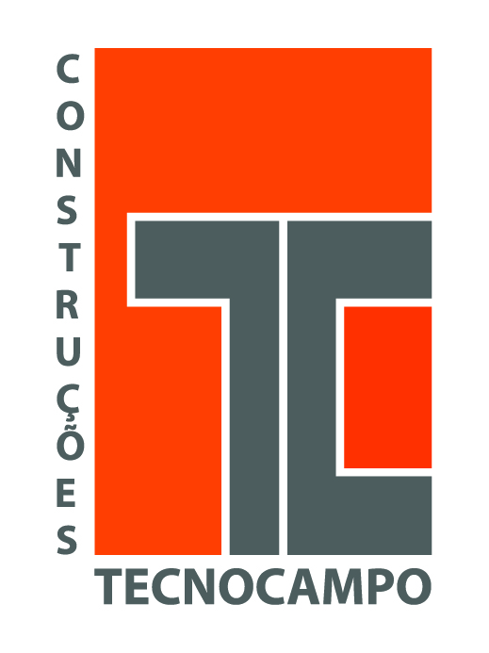
PRESS RELEASE
Tecnocampo - Construction, Rehabilitation and Maintenance

Tecnocampo, which is a company oriented to construction, rehabilitation and maintenance, has started its activity in 1998, in construction industry and public work, enhancing the construction of industrial and housing infrastructure.
With a solid experience in construction industry, the company from Pinto Brasil Group carries our all sort of architecture and specialties’ projects, industrial licensing and legalization of facilities. Thus, demonstrating ability not only related to traditional construction (buildings/ houses), but also related to metallic construction (houses/industrial plants) and infrastructure construction and it owns the specialized technical resources.
Tecnocampo is also enabled to provide the development of building rehabilitation, acting in different intervention areas, such as Facades, floors, roofs and interiors. Besides that, the company does the total rehabilitation of buildings, that can be degraded industrial buildings or buildings where modification processes are required.
When it comes to public works, Manuel Pinto Brasil, the group’s chairman, says that “Tecnocampo is able to carry out any construction, reconstruction, expansion, modification, repair, conservation, cleanliness, restoration, adaptation, improvement and demolition of immovable property which is meant to serve, by itself, an economic or technical function”.

Pinto Brasil Group started its activity in 1991, in the metalworking sector, specifically in the automotive wiring industry. In the meantime, over the past few years, the group expanded its potential as a machine and industrial peripheral supplier of some leading companies of the automotive and aeronautic sector, as well as expanded its business area to other sectors, such as industry, services, construction and IT.

