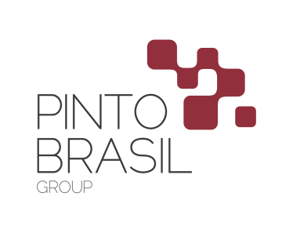

**PRESS RELEASE**

**Pinto Brasil Group - The Excellence of Your Business**

Headquarted in Guimarães, Pinto Brasil Group started activity in 1991, in the metalworking industry, specifically automotive wiring industry. In the meantime, over the past few years, the group has extended its potential as machines and industrial peripheral supplier of some leading companies of the automotive and aeronautic sector, as well as has expanded its business areas namely industry, services, construction and IT.

It is considered by its chairman, Manuel Pinto Brasil, “To be an organization that operates sustainably in different areas and markets whether national or international, which provides added value to our customers, employees and community”, Pinto Brasil Group’s growth strategy and position in the market is based on a constant development approach and in continuous improvement, know-how and management customer-oriented. As a consequence, this entrepreneurial vision has been opening doors to the group’s expansion regarding other countries, such as, Germany, Spain, Morocco, Mexico, Romania, Russia and Tunisia.

Currently, Pinto Brasil Group has 600 employees distributed by Pinto Brasil, Divmac, P.B. Renováveis, MTS Group, Arlógica / Inovar, Metalpaint, Calmways, Tecnocampo and GenSYS. The aforementioned companies are not only devoted to solve challenges but also to providing innovations in the market, regarding not only people’s evolvement, their integrity, coherence, professionalism and reliance but mostly their total satisfaction as well as commitment towards their customers and values.

**Manuel Machado Pinto Brasil**

**CEO of Pinto Brasil Group**

Manuel Machado Pinto Brasil is Pinto Brasil Group’s President and is directly and indirectly connected to all business areas of the group. He was born in Guimarães, in 1958, studied in Escola Comercial e Industrial of Guimarães and he has been working in the metalworking sector since he was 15 years old. His dynamic and entrepreneurial vision, unanimously recognized by his partners, customers and employees, stressed a unique identity to the group which is built on values as innovation, ambition, commitment, competency and accuracy.

*“Pinto Brasil Group has a strategic goal, the dynamic and continuous growth of its businesses through improvement of continuous processes, products and services, as well as the retraining of the Human Resources.*

*Since 1991, we have set a growth strategy in the industrial sector, diversified our activities, become internationalized and nowadays we are a very strong business group, which performs in several areas: Industry, Services, Construction and Information Technologies.*

*Through the fulfillment of our legal obligations, growth with sustainability will be assured. In compliance with these principals, we guarantee our values, beliefs, and our expectations as a group of responsible people.*

*People, Innovation, Partnerships, Responsibility, Ambition and sustainability: these are the greatest values in which Pinto Brasil Group is based on and which are common to all of the Group’s companies”.*